**StudyPlan**

Contents

Homepage 1

Menu Sidebar 2

Calendar Page 2

Tasks Page 3

Exam Page 3

New Task Page 4

*StudyPlan is a study planner to help you utilize 100% of your time. StudyPlan*

*is especially useful for students who need help with productivity and effective*

*time management.*

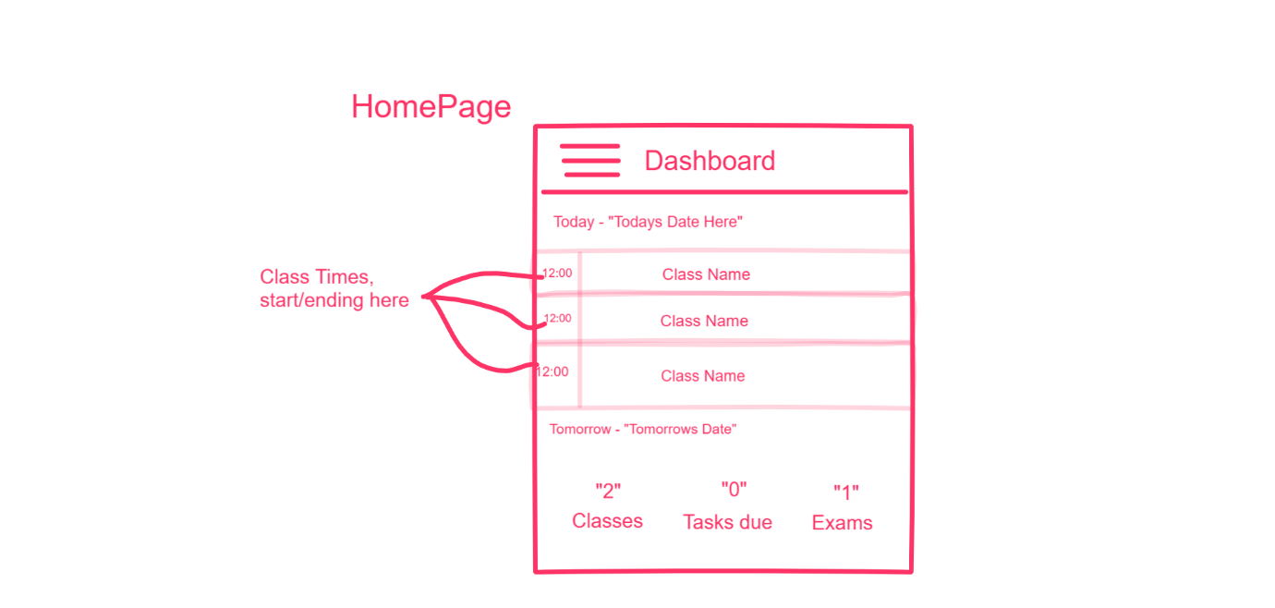

Menu



## Homepage

Fig1

* The sketch of the Homepage user interface shows regions that the user is going to interact with.



* There is a menu button that will display the dashboard button, calendar button, tasks button , schedule button, and a exams button.
* The dashboard page will display all the classes for the date today along with each classes start and ending time.There will also be a display for the amount of classes, tasks due and exams coming up .

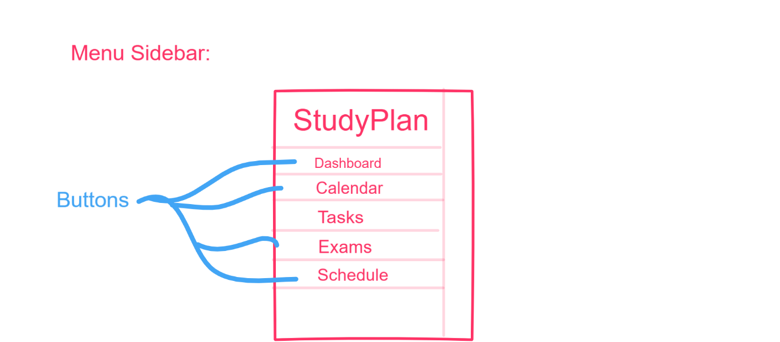

## Menu Sidebar

Fig 2

* The menu sidebar gives the user the options to look through each page on the app.

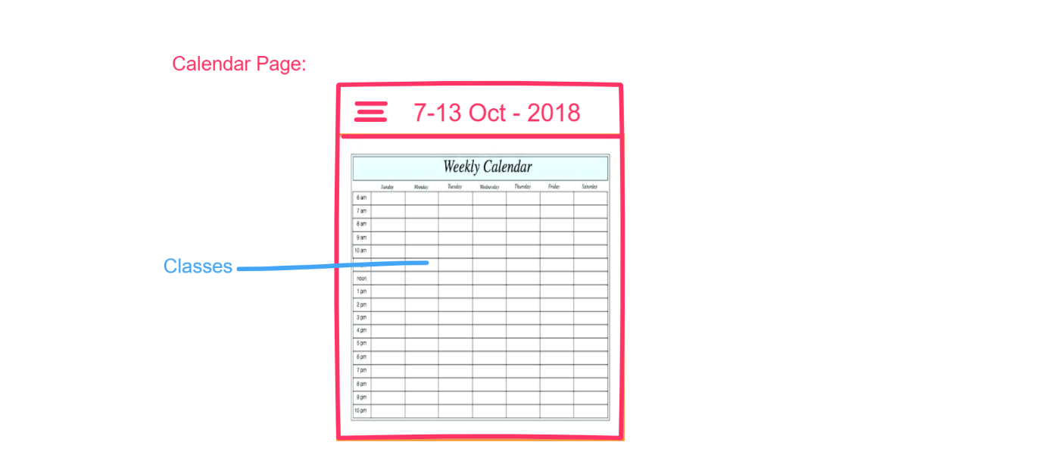

## Calendar Page

Fig 3

* The calendar page will allow the user to view their weekly classes that are on each day.

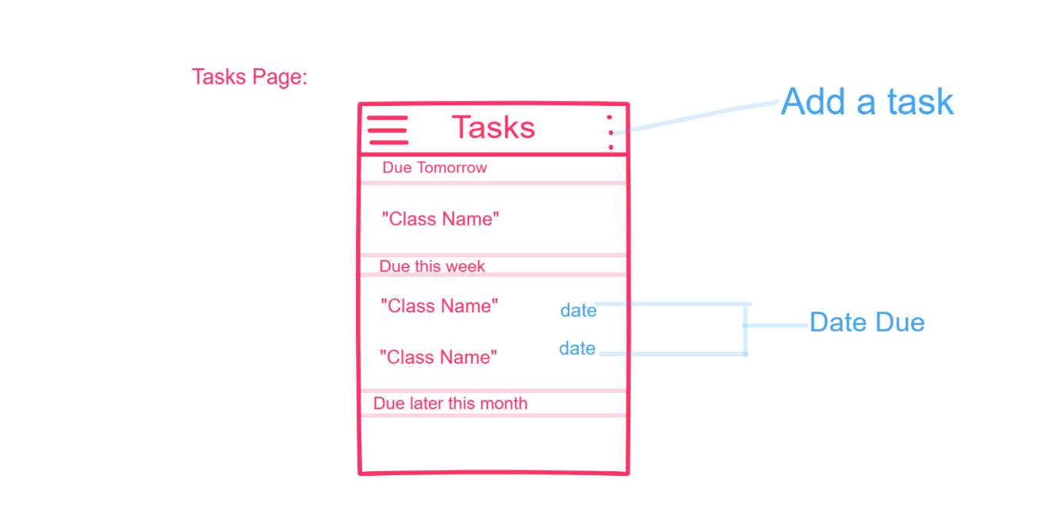

## Tasks Page

Fig 4

* The tasks page will allow the user to add tasks and view up coming tasks that are due.

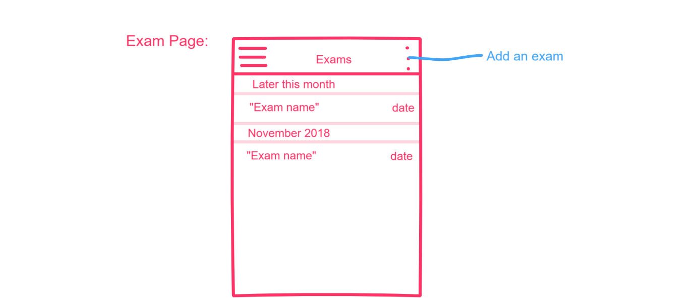

## Exam Page

Fig 5.

* The exam page will allow the user to add exams and view upcoming exams.

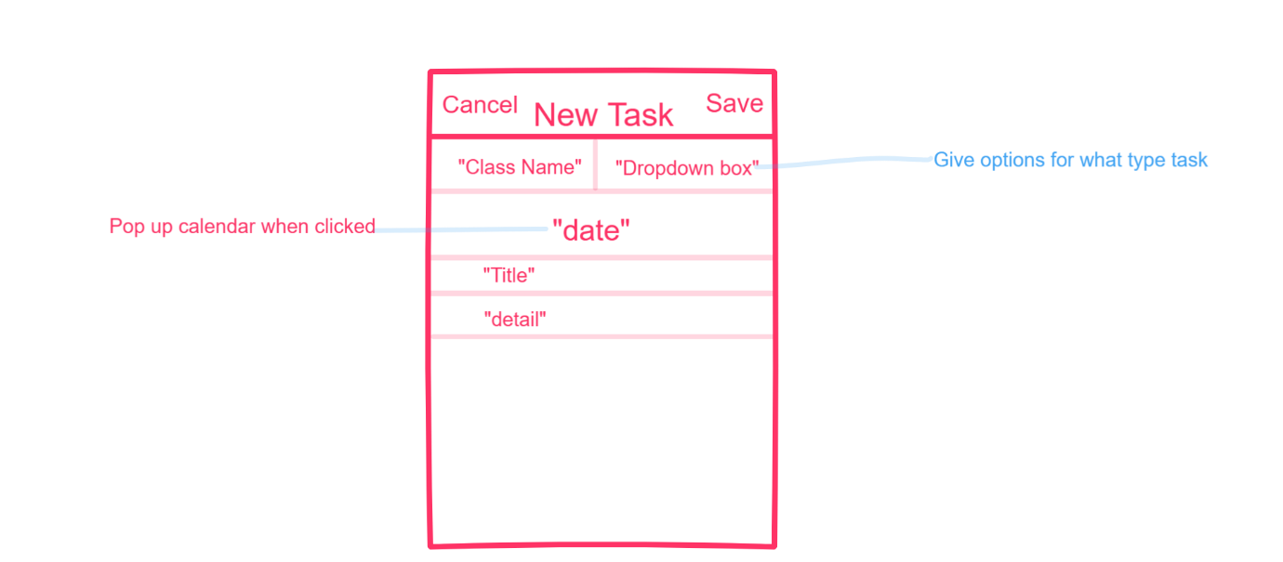

## New Task Page

Fig 6.

* The new task page will allow the user to add new tasks to the task page, the new exam page will be similar in style.